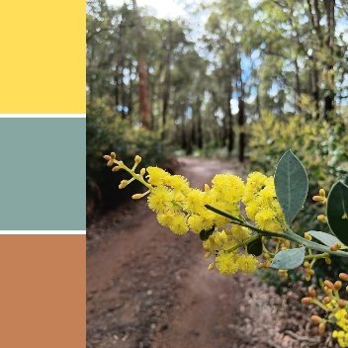
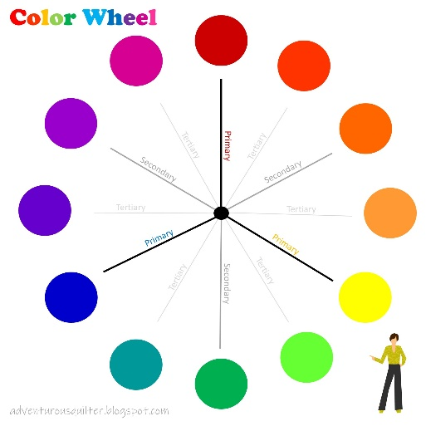
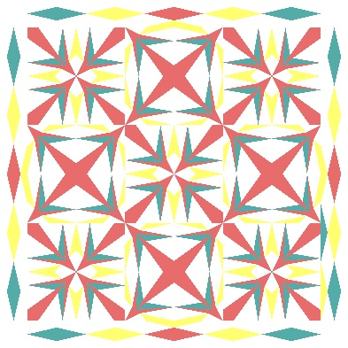
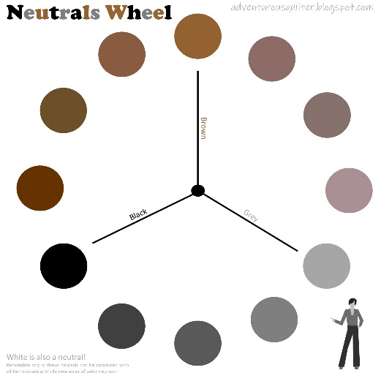
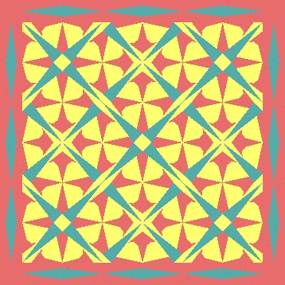
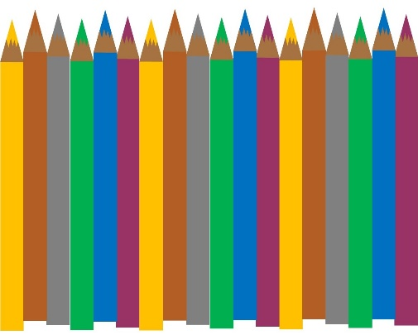
Color Study
Digital Worksheet Scrapbook
By Adventurous Quilter
Marianne Jeffrey
Weekly Color Study Task

- Take a photo of something beautiful you see this week that catches your eye

- Analyse the colors that are dominant in the photo (stick to 2 to 4 colors depending on the photo)

- Imagine quilts and/or sewing projects featuring those colors (you can imagine fabrics in solid or print)
©adventurous quilter Marianne Jeffrey
Resources

Color palette worksheet – if you would like to keep track of your color study work, I suggest keeping a worksheet each week in this digital scrapbook MS Word file!

This worksheet will encourage you to think beyond isolating colors and shades and you’ll need to identify things in the world around you that exist in similar colors to your weekly color focuses. The worksheet will also help you to envision the palettes in a quilt block.

Color Palette Worksheet EXAMPLE
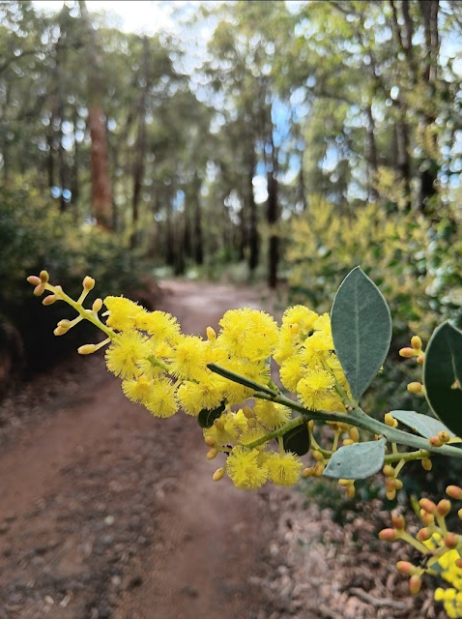
Photo and/or description of inspiration:

Color 1
©adventurous quilter Marianne Jeffrey
Web images of these colors used in real life
Wattle flower overhanging a red dirt road through the eucalypt forest
Analyse the color from your inspiration item/image
Show 3 to 4 dominant colors
Find fabrics to match
Color in the quilt block to show the palette in a star quilt block
Optional Color 4
Color 2
Color 3
Color Palette Worksheet

Photo and/or description of inspiration:

Color 1
Web images of these colors used in real life
©adventurous quilter Marianne Jeffrey
Analyse the color from your inspiration item/image
Show 3 to 4 dominant colors
Find fabrics to match
Color in the quilt block to show the palette in a star quilt block
Optional Color 4
Color 2
Color 3
Color Palette Worksheet

Photo and/or description of inspiration:

Color 1
Web images of these colors used in real life
Analyse the color from your inspiration item/image
Show 3 to 4 dominant colors
Find fabrics to match
Color in the quilt block to show the palette in a star quilt block
Optional Color 4
Color 2
Color 3
Color Palette Worksheet

Photo and/or description of inspiration:

Color 1
Web images of these colors used in real life
Analyse the color from your inspiration item/image
Show 3 to 4 dominant colors
Find fabrics to match
Color in the quilt block to show the palette in a star quilt block
Optional Color 4
Color 2
Color 3
Color Palette Worksheet

Photo and/or description of inspiration:

Color 1
Web images of these colors used in real life
Analyse the color from your inspiration item/image
Show 3 to 4 dominant colors
Find fabrics to match
Color in the quilt block to show the palette in a star quilt block
Optional Color 4
Color 2
Color 3
Color Palette Worksheet

Photo and/or description of inspiration:

Color 1
Web images of these colors used in real life
Analyse the color from your inspiration item/image
Show 3 to 4 dominant colors
Find fabrics to match
Color in the quilt block to show the palette in a star quilt block
Optional Color 4
Color 2
Color 3
Color Palette Worksheet

Photo and/or description of inspiration:

Color 1
Web images of these colors used in real life
Analyse the color from your inspiration item/image
Show 3 to 4 dominant colors
Find fabrics to match
Color in the quilt block to show the palette in a star quilt block
Optional Color 4
Color 2
Color 3
Color Palette Worksheet

Photo and/or description of inspiration:

Color 1
Web images of these colors used in real life
Analyse the color from your inspiration item/image
Show 3 to 4 dominant colors
Find fabrics to match
Color in the quilt block to show the palette in a star quilt block
Optional Color 4
Color 2
Color 3
Color Palette Worksheet

Photo and/or description of inspiration:

Color 1
Web images of these colors used in real life
Analyse the color from your inspiration item/image
Show 3 to 4 dominant colors
Find fabrics to match
Color in the quilt block to show the palette in a star quilt block
Optional Color 4
Color 2
Color 3
Color Palette Worksheet

Photo and/or description of inspiration:

Color 1
Web images of these colors used in real life
Analyse the color from your inspiration item/image
Show 3 to 4 dominant colors
Find fabrics to match
Color in the quilt block to show the palette in a star quilt block
Optional Color 4
Color 2
Color 3
Color Palette Worksheet

Photo and/or description of inspiration:

Color 1
Web images of these colors used in real life
Analyse the color from your inspiration item/image
Show 3 to 4 dominant colors
Find fabrics to match
Color in the quilt block to show the palette in a star quilt block
Optional Color 4
Color 2
Color 3
Color Palette Worksheet

Photo and/or description of inspiration:

Color 1
Web images of these colors used in real life
Analyse the color from your inspiration item/image
Show 3 to 4 dominant colors
Find fabrics to match
Color in the quilt block to show the palette in a star quilt block
Optional Color 4
Color 2
Color 3
Color Palette Worksheet

Photo and/or description of inspiration:

Color 1
Web images of these colors used in real life
Analyse the color from your inspiration item/image
Show 3 to 4 dominant colors
Find fabrics to match
Color in the quilt block to show the palette in a star quilt block
Optional Color 4
Color 2
Color 3
Color Palette Worksheet

Photo and/or description of inspiration:

Color 1
Web images of these colors used in real life
Analyse the color from your inspiration item/image
Show 3 to 4 dominant colors
Find fabrics to match
Color in the quilt block to show the palette in a star quilt block
Optional Color 4
Color 2
Color 3
Color Palette Worksheet

Photo and/or description of inspiration:

Color 1
Web images of these colors used in real life
Analyse the color from your inspiration item/image
Show 3 to 4 dominant colors
Find fabrics to match
Color in the quilt block to show the palette in a star quilt block
Optional Color 4
Color 2
Color 3
Color Palette Worksheet

Photo and/or description of inspiration:

Color 1
Web images of these colors used in real life
Analyse the color from your inspiration item/image
Show 3 to 4 dominant colors
Find fabrics to match
Color in the quilt block to show the palette in a star quilt block
Optional Color 4
Color 2
Color 3
Color Palette Worksheet

Photo and/or description of inspiration:

Color 1
Web images of these colors used in real life
Analyse the color from your inspiration item/image
Show 3 to 4 dominant colors
Find fabrics to match
Color in the quilt block to show the palette in a star quilt block
Optional Color 4
Color 2
Color 3
Color Palette Worksheet

Photo and/or description of inspiration:

Color 1
Web images of these colors used in real life
Analyse the color from your inspiration item/image
Show 3 to 4 dominant colors
Find fabrics to match
Color in the quilt block to show the palette in a star quilt block
Optional Color 4
Color 2
Color 3
Color Palette Worksheet

Photo and/or description of inspiration:

Color 1
Web images of these colors used in real life
Analyse the color from your inspiration item/image
Show 3 to 4 dominant colors
Find fabrics to match
Color in the quilt block to show the palette in a star quilt block
Optional Color 4
Color 2
Color 3
Color Palette Worksheet

Photo and/or description of inspiration:

Color 1
Web images of these colors used in real life
Analyse the color from your inspiration item/image
Show 3 to 4 dominant colors
Find fabrics to match
Color in the quilt block to show the palette in a star quilt block
Optional Color 4
Color 2
Color 3
Color Palette Worksheet

Photo and/or description of inspiration:

Color 1
Web images of these colors used in real life
Analyse the color from your inspiration item/image
Show 3 to 4 dominant colors
Find fabrics to match
Color in the quilt block to show the palette in a star quilt block
Optional Color 4
Color 2
Color 3
Color Palette Worksheet

Photo and/or description of inspiration:

Color 1
Web images of these colors used in real life
Analyse the color from your inspiration item/image
Show 3 to 4 dominant colors
Find fabrics to match
Color in the quilt block to show the palette in a star quilt block
Optional Color 4
Color 2
Color 3
Color Palette Worksheet

Photo and/or description of inspiration:

Color 1
Web images of these colors used in real life
Analyse the color from your inspiration item/image
Show 3 to 4 dominant colors
Find fabrics to match
Color in the quilt block to show the palette in a star quilt block
Optional Color 4
Color 2
Color 3
Color Palette Worksheet

Photo and/or description of inspiration:

Color 1
Web images of these colors used in real life
Analyse the color from your inspiration item/image
Show 3 to 4 dominant colors
Find fabrics to match
Color in the quilt block to show the palette in a star quilt block
Optional Color 4
Color 2
Color 3
Color Palette Worksheet

Photo and/or description of inspiration:

Color 1
Web images of these colors used in real life
Analyse the color from your inspiration item/image
Show 3 to 4 dominant colors
Find fabrics to match
Color in the quilt block to show the palette in a star quilt block
Optional Color 4
Color 2
Color 3
Color Palette Worksheet

Photo and/or description of inspiration:

Color 1
Web images of these colors used in real life
Analyse the color from your inspiration item/image
Show 3 to 4 dominant colors
Find fabrics to match
Color in the quilt block to show the palette in a star quilt block
Optional Color 4
Color 2
Color 3
Color Palette Worksheet

Photo and/or description of inspiration:

Color 1
Web images of these colors used in real life
Analyse the color from your inspiration item/image
Show 3 to 4 dominant colors
Find fabrics to match
Color in the quilt block to show the palette in a star quilt block
Optional Color 4
Color 2
Color 3
Color Palette Worksheet

Photo and/or description of inspiration:

Color 1
Web images of these colors used in real life
Analyse the color from your inspiration item/image
Show 3 to 4 dominant colors
Find fabrics to match
Color in the quilt block to show the palette in a star quilt block
Optional Color 4
Color 2
Color 3
Color Palette Worksheet

Photo and/or description of inspiration:

Color 1
Web images of these colors used in real life
Analyse the color from your inspiration item/image
Show 3 to 4 dominant colors
Find fabrics to match
Color in the quilt block to show the palette in a star quilt block
Optional Color 4
Color 2
Color 3
Color Palette Worksheet

Photo and/or description of inspiration:

Color 1
Web images of these colors used in real life
Analyse the color from your inspiration item/image
Show 3 to 4 dominant colors
Find fabrics to match
Color in the quilt block to show the palette in a star quilt block
Optional Color 4
Color 2
Color 3
Color Palette Worksheet

Photo and/or description of inspiration:

Color 1
Web images of these colors used in real life
Analyse the color from your inspiration item/image
Show 3 to 4 dominant colors
Find fabrics to match
Color in the quilt block to show the palette in a star quilt block
Optional Color 4
Color 2
Color 3
Color Palette Worksheet

Photo and/or description of inspiration:

Color 1
Web images of these colors used in real life
Analyse the color from your inspiration item/image
Show 3 to 4 dominant colors
Find fabrics to match
Color in the quilt block to show the palette in a star quilt block
Optional Color 4
Color 2
Color 3
Color Palette Worksheet

Photo and/or description of inspiration:

Color 1
Web images of these colors used in real life
Analyse the color from your inspiration item/image
Show 3 to 4 dominant colors
Find fabrics to match
Color in the quilt block to show the palette in a star quilt block
Optional Color 4
Color 2
Color 3
Color Palette Worksheet

Photo and/or description of inspiration:

Color 1
Web images of these colors used in real life
Analyse the color from your inspiration item/image
Show 3 to 4 dominant colors
Find fabrics to match
Color in the quilt block to show the palette in a star quilt block
Optional Color 4
Color 2
Color 3
Color Palette Worksheet

Photo and/or description of inspiration:

Color 1
Web images of these colors used in real life
Analyse the color from your inspiration item/image
Show 3 to 4 dominant colors
Find fabrics to match
Color in the quilt block to show the palette in a star quilt block
Optional Color 4
Color 2
Color 3
Color Palette Worksheet

Photo and/or description of inspiration:

Color 1
Web images of these colors used in real life
Analyse the color from your inspiration item/image
Show 3 to 4 dominant colors
Find fabrics to match
Color in the quilt block to show the palette in a star quilt block
Optional Color 4
Color 2
Color 3
Color Palette Worksheet

Photo and/or description of inspiration:

Color 1
Web images of these colors used in real life
Analyse the color from your inspiration item/image
Show 3 to 4 dominant colors
Find fabrics to match
Color in the quilt block to show the palette in a star quilt block
Optional Color 4
Color 2
Color 3
Color Palette Worksheet

Photo and/or description of inspiration:

Color 1
Web images of these colors used in real life
Analyse the color from your inspiration item/image
Show 3 to 4 dominant colors
Find fabrics to match
Color in the quilt block to show the palette in a star quilt block
Optional Color 4
Color 2
Color 3
Color Palette Worksheet

Photo and/or description of inspiration:

Color 1
Web images of these colors used in real life
Analyse the color from your inspiration item/image
Show 3 to 4 dominant colors
Find fabrics to match
Color in the quilt block to show the palette in a star quilt block
Optional Color 4
Color 2
Color 3
Color Palette Worksheet

Photo and/or description of inspiration:

Color 1
Web images of these colors used in real life
Analyse the color from your inspiration item/image
Show 3 to 4 dominant colors
Find fabrics to match
Color in the quilt block to show the palette in a star quilt block
Optional Color 4
Color 2
Color 3
Color Palette Worksheet

Photo and/or description of inspiration:

Color 1
Web images of these colors used in real life
Analyse the color from your inspiration item/image
Show 3 to 4 dominant colors
Find fabrics to match
Color in the quilt block to show the palette in a star quilt block
Optional Color 4
Color 2
Color 3
Color Palette Worksheet

Photo and/or description of inspiration:

Color 1
Web images of these colors used in real life
Analyse the color from your inspiration item/image
Show 3 to 4 dominant colors
Find fabrics to match
Color in the quilt block to show the palette in a star quilt block
Optional Color 4
Color 2
Color 3
Color Palette Worksheet

Photo and/or description of inspiration:

Color 1
Analyse the color from your inspiration item/image
Show 3 to 4 dominant colors
Find fabrics to match
Color in the quilt block to show the palette in a star quilt block
Optional Color 4
Color 2
Color 3
Web images of these colors used in real life
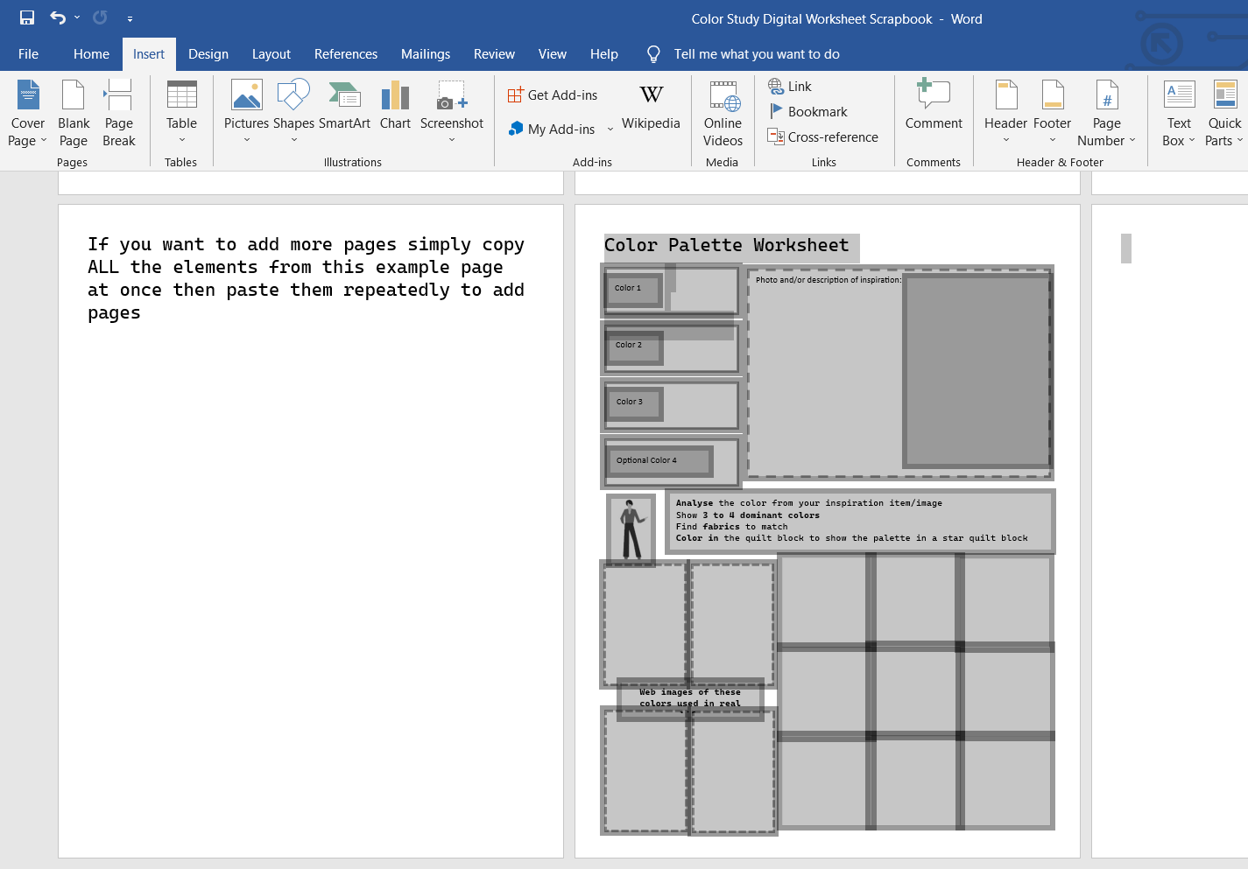
If you want to add more pages simply copy ALL the elements from this example page at once then paste them repeatedly to add pages to your digital scrapbook!
Color Palette Worksheet
©adventurous quilter Marianne Jeffrey

Photo and/or description of inspiration:

Color 1
Analyse the color from your inspiration item/image
Show 3 to 4 dominant colors
Find fabrics to match
Color in the quilt block to show the palette in a star quilt block
Optional Color 4
Color 2
Color 3
Web images of these colors used in real life

